**DR AMBEDKAR COLLEGE, DEEKSHA BHOOMI, NAGPUR**

**DEPARTMENT OF LAW**

**ACADEMIC SESSION: 2024-25**

|  |  |
| --- | --- |
| **NAME OF THE PROGRAMME:** | GUEST LECTURE ON  ‘ROLE OF FORENSIC EVIDENCE IN SECURING CONVICTIONS: CHALLENGES & CASE STUDIES’ |
| **NAME OF THE GUEST SPEAKER:** | DR ARCHANA SUKEY  PROF. WANJARI COLLEGE OF LAW  NAGPUR |
| **NAME OF THE PROGRAM SUPERVISOR:** | DR VARSHA .V. DESHPANDE |
| **NAME OF THE PROGRAM**  **CO-ORDINATOR:** | DR SANDHYA .P. KALAMDHAD |
| **DATE & DAY:** | 05th April 2025, SATURDAY |
| **TIME:** | 11.30 AM |
| **TOTAL NUMBER OF PARTICIPANTS:** | 75 |
| **VENUE:** | SEMINAR HALL,  DEPARTMENT OF LAW. |

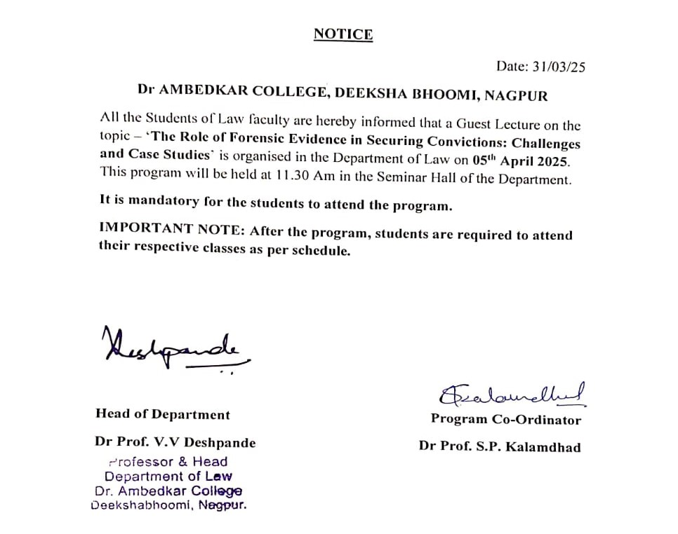

The guest lecture was held in association with **‘CODE F SOLUTIONS PRIVATE LIMITED’** with whom the Department of Law has undergone a MOU. The lecture aimed to provide an in-depth understanding of how forensic science intersects with criminal law to uphold justice. The session began with an overview of forensic evidence types, including DNA analysis, fingerprint identification, digital forensics, and trace evidence. The speaker emphasized the importance of proper evidence collection and preservation to ensure its admissibility in court. Specific case studies were discussed to demonstrate the impact of forensic evidence in legal proceedings. These included:

1. **The O.J. Simpson Trial (1995):** This case highlighted the significance of DNA evidence in criminal investigations. While forensic evidence played a pivotal role, it also revealed how mishandling or miscommunication of forensic findings could influence a jury's perception.
2. **The BTK Killer Case (Dennis Rader, 2005):** The use of advanced forensic techniques, such as DNA analysis from a familial match, ultimately led to the identification and conviction of the serial killer, demonstrating the evolving capabilities of forensic science.
3. **The Aarushi Talwar Case (India, 2008):** This case illustrated the challenges posed by forensic errors, including improper handling of evidence and contentious interpretations, which complicated the legal proceedings and raised questions about the reliability of forensic practices.

The speaker provided valuable insights into how these cases shaped forensic protocols and underscored the need for accuracy and integrity in evidence processing. The lecture also addressed challenges and ethical dilemmas faced by forensic scientists and legal professionals, such as the reliability of certain forensic methods, potential biases, and the consequences of flawed evidence leading to wrongful convictions. Students were encouraged to critically analyse the limitations and possibilities of forensic science in legal contexts.

A robust Q&A session followed, allowing students to engage with the speaker and gain clarity on various aspects of forensic science and its implications for criminal law practice. In conclusion, the guest lecture successfully shed light on the vital connection between forensic science and the legal framework, equipping students with valuable knowledge and insights for their future careers in criminal law. We extend our gratitude to Dr Archana Sukey for sharing their expertise and enriching the academic experience of our students.

